Source Code:
#include <stdio.h>
int gcd_iterative(int a, int b) {// Iterative GCD
while (b != 0) {
int temp = b;
b = a % b;
a = temp;
}
return a;
}
// Recursive GCD
int gcd_recursive(int a, int b) {
if (b == 0)
return a;
return gcd_recursive(b, a % b);
}
int main() {
int a = 56, b = 98;
printf("Iterative GCD of %d and %d is: %d\n", a, b, gcd_iterative(a, b));
printf("Recursive GCD of %d and %d is: %d\n", a, b, gcd_recursive(a, b));
return 0;
}

Output:
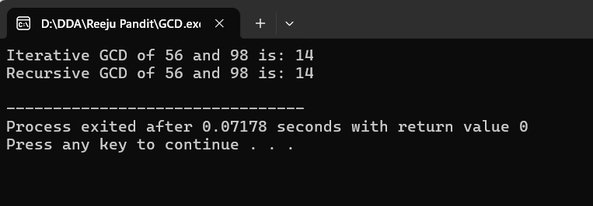

Source Code:
#include <stdio.h>
void fibonacci_iterative(int n) {
int a = 0, b = 1, next;
printf("Fibonacci Series up to %d terms: ", n);
for (int i = 1; i <= n; i++) {
if (i == 1) {
printf("%d ", a);
continue;
}
if (i == 2) {
printf("%d ", b);
continue;
}
next = a + b;
a = b;
b = next;
printf("%d ", next);
}
printf("\n");
}
int main() {
int n = 10;
fibonacci_iterative(n);
return 0;
}
Output: 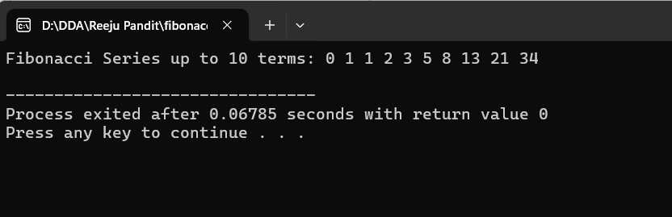

Source Code:
#include <stdio.h>

void print_array(int arr[], int n) {
printf("Array: ");
for (int i = 0; i < n; i++) {
printf("%d ", arr[i]);
}
printf("\n");
}
int linear_search(int arr[], int n, int target) {
for (int i = 0; i < n; i++) {
if (arr[i] == target)
return i;
}
return -1;
}

int main() {
int arr[] = {5, 3, 8, 6, 2};
int n = sizeof(arr) / sizeof(arr[0]);
int target = 6;
int result = linear_search(arr, n, target);
if (result != -1)
printf("Element found at index: %d\n", result);
else
printf("Element not found\n");
return 0;
}
Output:
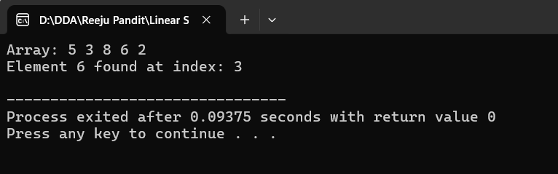
Source code:
#include <stdio.h>
void print_array(int arr[], int n) {
printf("Array: ");
for (int i = 0; i < n; i++) {
printf("%d ", arr[i]);
}
printf("\n");
}
int binary_search_iterative(int arr[], int n, int target) {
int left = 0, right = n - 1;
while (left <= right) {
int mid = left + (right - left) / 2;
if (arr[mid] == target)
return mid;
if (arr[mid] < target)
left = mid + 1;
else
right = mid - 1;
}
return -1;
}

int binary_search_recursive(int arr[], int left, int right, int target) {
if (right >= left) {
int mid = left + (right - left) / 2;
if (arr[mid] == target)
return mid;
if (arr[mid] > target)
return binary_search_recursive(arr, left, mid - 1, target);
return binary_search_recursive(arr, mid + 1, right, target);
}
return -1;
}

int main() {
int arr[] = {2, 5, 7, 10, 15, 20, 25};
int n = sizeof(arr) / sizeof(arr[0]);
int target = 10;
print_array(arr, n);
// Perform iterative and recursive binary searches
int iterative_result = binary_search_iterative(arr, n, target);
int recursive_result = binary_search_recursive(arr, 0, n - 1, target);
// Display results
if (iterative_result != -1)
printf("Iterative Binary Search: Element %d found at index: %d\n", target, iterative_result);
else
printf("Iterative Binary Search: Element %d not found\n", target);
if (recursive_result != -1)
printf("Recursive Binary Search: Element %d found at index: %d\n", target, recursive_result);
else
printf("Recursive Binary Search: Element %d not found\n", target);
return 0;
Output:

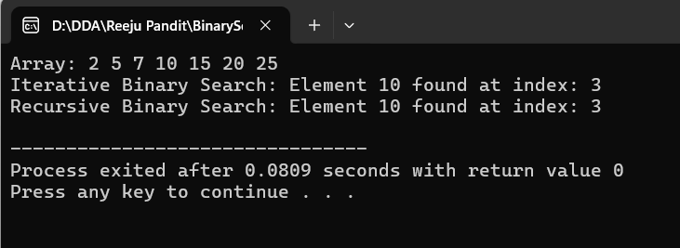

Source Code:
#include <stdio.h>
void print_array(int arr[], int n) {
printf("Array: ");
for (int i = 0; i < n; i++) {
printf("%d ", arr[i]);
}
printf("\n");
}
void selection_sort(int arr[], int n) {
for (int i = 0; i < n - 1; i++) {
int min_index = i;
for (int j = i + 1; j < n; j++) {
if (arr[j] < arr[min_index]) {
min_index = j;
}
}
int temp = arr[min_index];
arr[min_index] = arr[i];
arr[i] = temp;
}
}

int main() {
int arr[] = {64, 25, 12, 22, 11};
int n = sizeof(arr) / sizeof(arr[0]);
printf("Before Sorting:\n");
print_array(arr, n);
selection_sort(arr, n);
printf("After Sorting:\n");
print_array(arr, n);
printf("\n");
return 0;
}
Output:
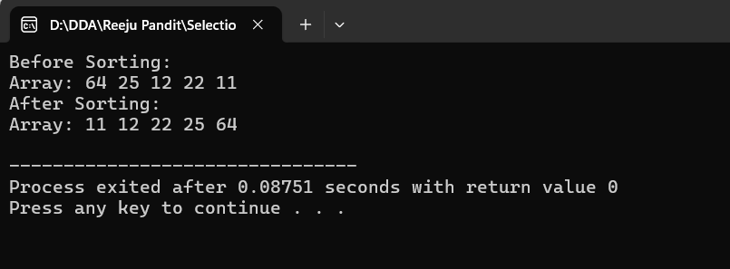

Source Code:
#include <stdio.h>

void insertion_sort(int arr[], int n) {
for (int i = 1; i < n; i++) {
int key = arr[i];
int j = i - 1;
while (j >= 0 && arr[j] > key) {
arr[j + 1] = arr[j];
j = j - 1;
}
arr[j + 1] = key;
}
}

int main() {
int arr[] = {12, 11, 13, 5, 6}; // Predefined array
int n = sizeof(arr) / sizeof(arr[0]);

printf("Before Sorting: ");
for (int i = 0; i < n; i++) {
printf("%d ", arr[i]);
}
printf("\n");

insertion_sort(arr, n); // Perform the sorting

printf("After Sorting: ");
for (int i = 0; i < n; i++) {
printf("%d ", arr[i]);
}
printf("\n");

return 0;
}
Output:
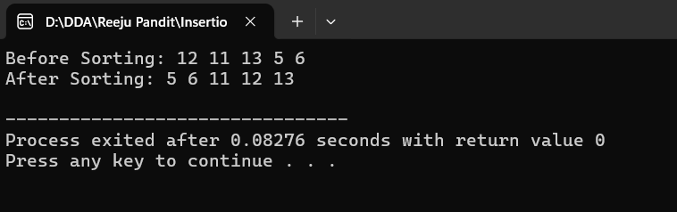

Source Code:
#include <stdio.h>

void min_max_sort(int arr[], int n) {
for (int i = 0; i < n / 2; i++) {
int min_index = i, max_index = i;
// Find the minimum and maximum in the remaining unsorted part
for (int j = i + 1; j < n - i; j++) {
if (arr[j] < arr[min_index]) {
min_index = j;
}
if (arr[j] > arr[max_index]) {
max_index = j;
}
}

// Swap the minimum element with the first element
int temp = arr[i];
arr[i] = arr[min_index];
arr[min_index] = temp;

// Adjust the maximum index if it was swapped
if (max_index == i) {
max_index = min_index;
}

// Swap the maximum element with the last element
temp = arr[n - 1 - i];
arr[n - 1 - i] = arr[max_index];
arr[max_index] = temp;
}
}

int main() {
int arr[] = {3, 5, 1, 10, 4}; // Predefined array
int n = sizeof(arr) / sizeof(arr[0]);

printf("Before Sorting: ");
for (int i = 0; i < n; i++) {
printf("%d ", arr[i]);
}
printf("\n");

min_max_sort(arr, n); // Perform the sorting

printf("After Sorting: ");
for (int i = 0; i < n; i++) {
printf("%d ", arr[i]);
}
printf("\n");

return 0;
}
Output:
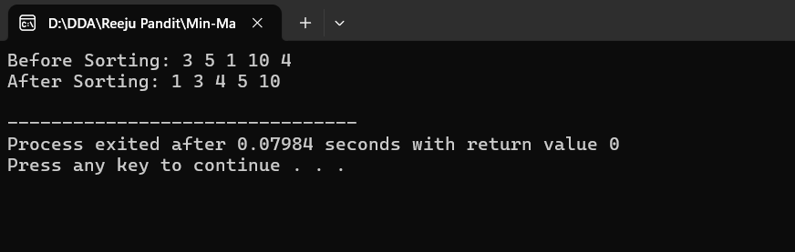

Source code:
#include <stdio.h>
// Merge function to combine two halves
void merge(int arr[], int left, int mid, int right) {
int n1 = mid - left + 1;
int n2 = right - mid;

// Create temporary arrays
int leftArr[n1], rightArr[n2];

// Copy data to temp arrays
for (int i = 0; i < n1; i++)
leftArr[i] = arr[left + i];
for (int i = 0; i < n2; i++)
rightArr[i] = arr[mid + 1 + i];

// Merge the temp arrays back into the original array
int i = 0, j = 0, k = left;
while (i < n1 && j < n2) {
if (leftArr[i] <= rightArr[j]) {
arr[k] = leftArr[i];
i++;
} else {
arr[k] = rightArr[j];
j++;
}
k++;
}

// Copy remaining elements of leftArr[], if any
while (i < n1) {
arr[k] = leftArr[i];
i++;
k++;
}

// Copy remaining elements of rightArr[], if any
while (j < n2) {
arr[k] = rightArr[j];
j++;
k++;
}
}

// Merge Sort function
void merge_sort(int arr[], int left, int right) {
if (left < right) {
int mid = left + (right - left) / 2;
merge_sort(arr, left, mid); // Sort first half
merge_sort(arr, mid + 1, right); // Sort second half
merge(arr, left, mid, right); // Merge both halves
}
}

int main() {
int arr[] = {12, 11, 13, 5, 6, 7}; // Predefined array
int n = sizeof(arr) / sizeof(arr[0]);

printf("Before Sorting: ");
for (int i = 0; i < n; i++) {
printf("%d ", arr[i]);
}
printf("\n");

merge_sort(arr, 0, n - 1); // Perform the sorting

printf("After Sorting: ");
for (int i = 0; i < n; i++) {
printf("%d ", arr[i]);
}
printf("\n");

return 0;
}

Output:
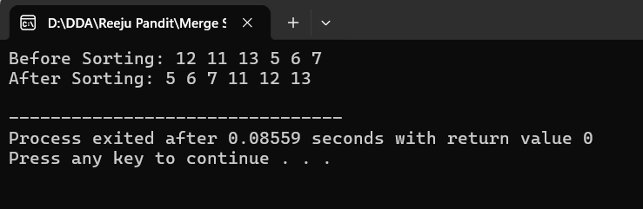

Source Code:
#include <stdio.h>

// Function to perform the partitioning
int partition(int arr[], int low, int high) {
int pivot = arr[high]; // Last element as pivot
int i = (low - 1); // Index of smaller element

for (int j = low; j <= high - 1; j++) {
if (arr[j] < pivot) {
i++; // Increment index of smaller element
int temp = arr[i];
arr[i] = arr[j];
arr[j] = temp;
}
}

int temp = arr[i + 1];
arr[i + 1] = arr[high];
arr[high] = temp;

return (i + 1);
}

// Quick Sort function
void quick_sort(int arr[], int low, int high) {
if (low < high) {
int pi = partition(arr, low, high); // Partitioning index

quick_sort(arr, low, pi - 1); // Sort elements before partition
quick_sort(arr, pi + 1, high); // Sort elements after partition
}
}

int main() {
int arr[] = {10, 7, 8, 9, 1, 5}; // Predefined array
int n = sizeof(arr) / sizeof(arr[0]);

printf("Before Sorting: ");
for (int i = 0; i < n; i++) {
printf("%d ", arr[i]);
}
printf("\n");

quick_sort(arr, 0, n - 1); // Perform the sorting

printf("After Sorting: ");
for (int i = 0; i < n; i++) {
printf("%d ", arr[i]);
}
printf("\n");
return 0;
}

Output:
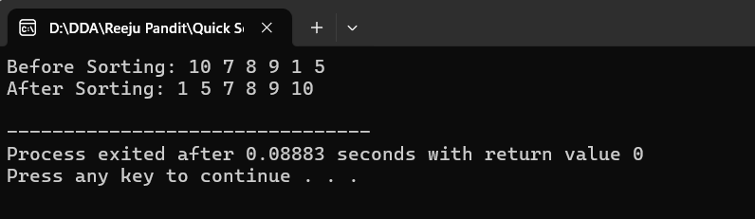

Source Code:
#include <stdio.h>
#include <stdlib.h>
#include <time.h>

int partition(int arr[], int low, int high) {
int pivot = arr[high];
int i = (low - 1);
for (int j = low; j <= high - 1; j++) {
if (arr[j] < pivot) {
i++;
int temp = arr[i];
arr[i] = arr[j];
arr[j] = temp;
}
}
int temp = arr[i + 1];
arr[i + 1] = arr[high];
arr[high] = temp;
return (i + 1);
}

void randomized_quick_sort(int arr[], int low, int high) {
if (low < high) {
// Randomly select a pivot
int random = low + rand() % (high - low);
int temp = arr[random];
arr[random] = arr[high];
arr[high] = temp;

int pi = partition(arr, low, high);
randomized_quick_sort(arr, low, pi - 1);
randomized_quick_sort(arr, pi + 1, high);
}
}
void print_array(int arr[], int n) {
for (int i = 0; i < n; i++) {
printf("%d ", arr[i]);
}
printf("\n");
}
int main() {
srand(time(NULL)); // Seed the random number generator
int arr[] = {10, 7, 8, 9, 1, 5}; // Predefined array
int n = sizeof(arr) / sizeof(arr[0]);
printf("Before Sorting: ");
print_array(arr, n); // Print the array before sorting
randomized_quick_sort(arr, 0, n - 1); // Perform the sorting
printf("After Sorting: ");
print_array(arr, n); // Print the array after sorting
return 0;
}
Output:
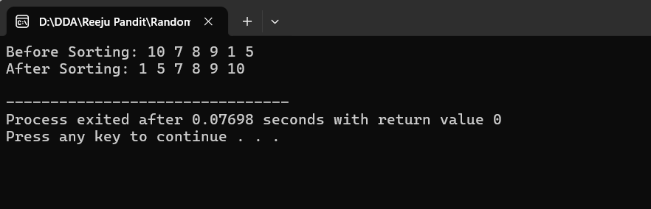

Source Code:
#include <stdio.h>
void heapify(int arr[], int n, int i) {
int largest = i;
int left = 2 * i + 1;
int right = 2 * i + 2;
if (left < n && arr[left] > arr[largest])
largest = left;
if (right < n && arr[right] > arr[largest])
largest = right;
if (largest != i) {
int temp = arr[i];
arr[i] = arr[largest];
arr[largest] = temp;

heapify(arr, n, largest);
}
}
void heap_sort(int arr[], int n) {
// Build heap (rearrange array)
for (int i = n / 2 - 1; i >= 0; i--)
heapify(arr, n, i);

// One by one extract elements from heap
for (int i = n - 1; i >= 1; i--) {
// Move current root to end
int temp = arr[0];
arr[0] = arr[i];
arr[i] = temp;

// Call heapify on the reduced heap
heapify(arr, i, 0);
}
}
void print_array(int arr[], int n) {
for (int i = 0; i < n; i++) {
printf("%d ", arr[i]);
}
printf("\n");
}

int main() {
int arr[] = {12, 11, 13, 5, 6, 7};
int n = sizeof(arr) / sizeof(arr[0]);
printf("Before Sorting: ");
print_array(arr, n); // Print array before sorting
heap_sort(arr, n); // Perform heap sort
printf("After Sorting: ");
print_array(arr, n); // Print array after sorting

return 0;
}
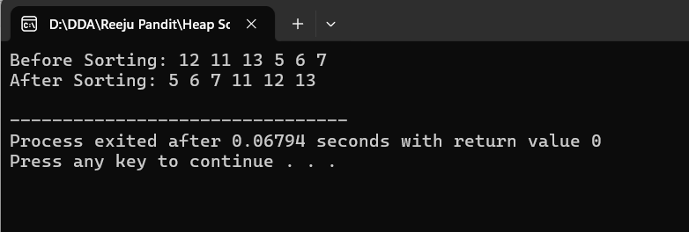

Source Code:

#include <stdio.h>
#include <stdlib.h>

// Structure to represent an item
struct Item {
int value;
int weight;
};

// Comparison function to sort items based on value/weight ratio
int compare(const void* a, const void* b) {
double r1 = ((struct Item*)a)->value / (double)((struct Item*)a)->weight;
double r2 = ((struct Item*)b)->value / (double)((struct Item*)b)->weight;
if (r1 < r2)
return 1;
else
return -1;
}

// Function to solve the fractional knapsack problem
double fractional_knapsack(int W, struct Item arr[], int n) {
qsort(arr, n, sizeof(arr[0]), compare); // Sort items based on value/weight ratio

int currentWeight = 0;
double finalValue = 0.0;

// Print the sorted items
printf("Sorted items by value/weight ratio:\n");
for (int i = 0; i < n; i++) {
printf("Item %d: Value = %d, Weight = %d, Value/Weight = %.2f\n", i+1, arr[i].value, arr[i].weight, (double)arr[i].value / arr[i].weight);
}

// Iterating through items to select them for the knapsack
printf("\nItems selected:\n");
for (int i = 0; i < n; i++) {
if (currentWeight + arr[i].weight <= W) {
currentWeight += arr[i].weight;
finalValue += arr[i].value;
printf("Full item taken: Value = %d, Weight = %d\n", arr[i].value, arr[i].weight);
} else {
int remainingWeight = W - currentWeight;
finalValue += arr[i].value * ((double)remainingWeight / arr[i].weight);
printf("Partial item taken: Value = %.2f, Weight = %d (Fraction: %.2f)\n", arr[i].value * ((double)remainingWeight / arr[i].weight), remainingWeight, (double)remainingWeight / arr[i].weight);
break;
}
}

return finalValue;
}

int main() {
struct Item arr[] = {{60, 10}, {100, 20}, {120, 30}};
int W = 50; // Capacity of knapsack
int n = sizeof(arr) / sizeof(arr[0]);

// Displaying input
printf("Input items:\n");
for (int i = 0; i < n; i++) {
printf("Item %d: Value = %d, Weight = %d\n", i + 1, arr[i].value, arr[i].weight);
}

// Call the function and display result
printf("\nMaximum value in Knapsack = %.2f\n", fractional_knapsack(W, arr, n));
return 0;
}

Output:
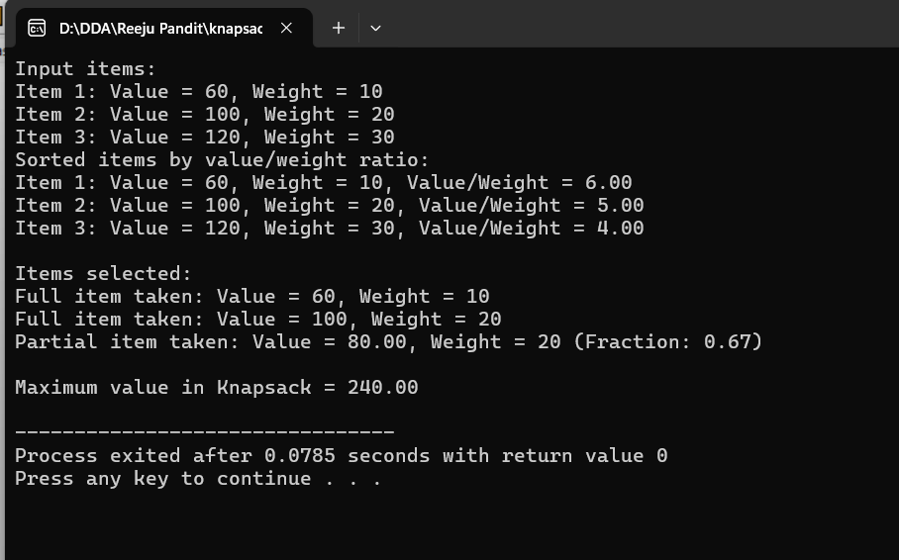

Source Code:
#include <stdio.h>
#include <stdbool.h>
#include <stdlib.h>

// Structure to represent a job
struct Job {
int id;
int deadline;
int profit;
};

// Comparison function to sort jobs in decreasing order of profit
int compare(const void* a, const void* b) {
return ((struct Job*)b)->profit - ((struct Job*)a)->profit;
}

// Function to find the job sequence with maximum profit
void job_sequencing(struct Job arr[], int n) {
qsort(arr, n, sizeof(arr[0]), compare); // Sort jobs by profit in descending order

int result[n]; // Array to store the sequence of jobs
bool slot[n]; // Array to check if a slot is already filled
for (int i = 0; i < n; i++)
slot[i] = false;

// Sequence jobs in slots to maximize profit
for (int i = 0; i < n; i++) {
// Find a free slot for this job
for (int j = arr[i].deadline - 1; j >= 0; j--) {
if (!slot[j]) {
result[j] = i;
slot[j] = true;
break;
}
}
}

// Print the job sequence with maximum profit
printf("Job sequence with maximum profit:\n");
for (int i = 0; i < n; i++) {
if (slot[i]) {
printf("Job %d (Profit: %d) -> ", arr[result[i]].id, arr[result[i]].profit);
}
}
printf("\n");
}

int main() {
struct Job arr[] = {{1, 2, 100}, {2, 1, 19}, {3, 2, 27}, {4, 1, 25}, {5, 3, 15}};
int n = sizeof(arr) / sizeof(arr[0]);

// Display input jobs
printf("Input Jobs (ID, Deadline, Profit):\n");
for (int i = 0; i < n; i++) {
printf("Job %d: Deadline = %d, Profit = %d\n", arr[i].id, arr[i].deadline, arr[i].profit);
}

// Call the job sequencing function
job_sequencing(arr, n);
return 0;
}

Output:
